Infosys Springboard Virtual Internship 6.0
Completion Report

Team Details <Do not mention any personally identifiable information like email ID, institute details, mobile phone number etc.>

Batch 6 team C: AirAware Smart Air Quality Prediction Training Program

Start date : 10-09-2025

Names:
- Machika Kapil
- Sharmika Gangadharan
- Joseph Alvis Sajith

Internship Duration: 40-day ( 12 Weeks )

.

1. Project Title
AirAware Smart Air Quality Prediction Training Program

2. Project Objective
AirWare is an AI-enabled air quality monitoring and prediction platform designed to provide real-time environmental insights and decision support. Its core objectives are to:
- Monitor and display real-time air quality parameters such as AQI, PM2.5, CO, and NO₂ through an interactive web-based dashboard.
- Visualize air pollution trends using heatmaps, line charts, and pie charts to improve data interpretability and awareness.
- Predict Air Quality Index (AQI) values using a machine learning–based Random Forest model for proactive environmental assessment.
- Assist users through an AI-powered chatbot (Gork API) that provides air quality explanations, health guidance, and pollution-related insights.
- Collect user feedback and communicate it efficiently to administrators via an email-based feedback system.
The project enhances traditional air quality monitoring approaches by combining machine learning, artificial intelligence, and full-stack web development to deliver a scalable, data-driven, and user-centric solution that supports public awareness, environmental analysis, and informed decision-making.

3. Project description in detail
The AirWare project is an AI-driven web-based air quality monitoring and prediction platform designed to provide real-time environmental data, predictive insights, and intelligent user assistance. The system integrates live API data, machine learning models, and full-stack web technologies to deliver accurate and actionable air quality information.
The platform functions through the following workflow:
- Live Air Quality Data Acquisition
  - Real-time pollutant data including PM2.5, PM10, SO₂, and NO₂ is fetched using the OpenWeather Air Pollution API.
  - These live values serve as the primary input for air quality analysis and prediction.
- Machine Learning–Based AQI Calculation
  - A Random Forest Regression model is trained using a historical air quality dataset sourced from Kaggle.
  - The model uses PM2.5, PM10, SO₂, and NO₂ as input features to predict the Air Quality Index (AQI).
  - Model performance demonstrates high accuracy with:
    - RMSE: 6.02
    - R² Score: 0.9956
  - This indicates highly reliable AQI prediction closely aligned with real-world values.
- Backend Processing and API Layer
  - The backend is developed using Flask (Python).
  - It handles:
    - Fetching live pollutant data from OpenWeather
    - Passing pollutant values to the trained ML model
    - Returning predicted AQI values to the frontend via RESTful APIs
- Frontend Dashboard and Visualization
  - A responsive dashboard displays:
    - Live pollutant concentrations (PM2.5, PM10, SO₂, NO₂)
    - Predicted AQI values generated by the ML model
    - Provides necessary precautions to be taken based on the AQI level.
  - Data visualization is implemented using:
    - Heatmap showcasing AQI levels of the past 7 days.
    - Line charts for AQI trend analysis
    - Pie charts for pollutant contribution representation
    - Line chart for AQI forecast of next 2 days
  - These visual elements improve interpretability and user awareness.
- AI-Powered Chatbot Integration
  - An intelligent chatbot powered by the Grok API assists users by:
    - Explaining AQI levels and pollution categories
    - Providing health-related advice based on air quality
    - Answering general air pollution–related queries
  - This feature enhances accessibility and user engagement.
- Feedback and Email Communication System
  - A feedback module allows users to submit comments and suggestions.
  - The backend uses Python’s smtplib to send feedback emails directly to the administrator.
  - This ensures reliable communication without reliance on third-party email services.
- Overall System Impact
  - AirWare replaces static air quality reporting with a dynamic, predictive, and intelligent system.
  - By combining live environmental data, machine learning–based AQI prediction, AI-driven assistance, and data visualization, the platform supports public awareness, health-conscious decision-making, and environmental sustainability.
.
4.

Week | Activities Planned | Activities Completed
Week 1 | Requirement study, use-case mapping | Problem definition refined, objectives finalized
Week 2 | Technology stack selection, system architecture design | Flask backend structure designed, OpenWeather API selected
Week 3 |  | Dashboard UI skeleton created with state selection and navigation
  User authentication module (Signup/Login)
Week 4 | Basic frontend layout and navigation | Dashboard UI skeleton created with state selection and navigation
Week 5 |  | Hourly, daily, and monthly AQI charts implemented
  Data visualization and trend analysis
Week 6 | Core backend–frontend integration | Backend APIs connected with frontend dashboard components
Week 7 | Machine Learning model data acquisition and preprocessing | Dataset available in Kaggle (PM2.5, PM10, SO₂, NO₂ data) is taken and cleaned for training.
Week 8 | ML model evaluation and integration | Random Forest model trained using Kaggle dataset and integrated into backend
Week 9 | Chatbot integration | Added chatbot to the webpage with the grok api
Week 10 | AQI forecast and safety analysis features | OpenWeather AQI forecast and safety recommendations based on aqi level.
Week 11 | Google OAuth integration | Google Sign-In implemented with secure session-based authentication
Week 12 | User personalization, testing, documentation | Favorite state feature, profile management, sharing options, testing, and final documentation completed

5a. Key Milestones

Milestone | Description | Date Achieved
Project Kickoff | Defined project objectives, scope, responsibilities, and success criteria. | 10 Nov 2025
Prototype / First Draft | Developed initial working prototype covering resume parsing, matching logic, and UI flow. | 20 Nov 2025
Mid-Term Review | Conducted review to evaluate progress, refine feature priorities, and implement improvement actions. | 4 Dec 2025
Final Submission | Completed and submitted the fully functional AirAware system with reporting and documentation. | 18 Dec 2025
Final Presentation | Delivered demonstration highlighting system architecture, functionality, results, and impact. | 30 Dec 2025

5b. Project execution details

The execution of the AirAware system followed a structured, modular, and iterative development approach, focusing on real-time air quality monitoring, data-driven prediction, and user-centric visualization.
The project began with problem identification and requirement analysis, where the growing impact of air pollution on public health was studied. Key objectives were defined, including real-time AQI monitoring, pollutant-level analysis, short-term forecasting, and user personalization. Government AQI standards and health advisory guidelines were reviewed to ensure domain correctness. Based on this analysis, system requirements and functional modules were finalized.
Subsequently, the technology stack and system architecture were designed. A Flask-based backend was selected for its lightweight and modular nature, while SQLite was used for persistent user data storage. The OpenWeather API was chosen as the primary data source for live pollutant concentrations (PM2.5, PM10, SO₂, NO₂). The frontend was planned using HTML, CSS, and JavaScript with a dashboard-oriented layout for effective data visualization.
Following this, user authentication and session management were implemented. Secure signup and login functionality using email and password hashing was developed, along with Google OAuth integration to provide seamless third-party authentication. Session-based access control ensured secure navigation across the dashboard, profile, and personalized features.
Once the core backend and frontend framework was established, live air quality data integration was performed. Real-time pollutant values were fetched from the OpenWeather API based on user-selected Indian states. These values were processed to compute AQI using standard sub-index calculations, enabling consistent and accurate air quality representation across the application.
After establishing the real-time AQI pipeline, a machine learning-based AQI prediction module was developed. A Random Forest regression model was trained using historical air quality data sourced from Kaggle, with PM2.5, PM10, SO₂, and NO₂ as input features. The model demonstrated high prediction accuracy and was integrated into the backend to compute AQI values from pollutant concentrations, enhancing the system’s analytical capability beyond raw API indices.
In parallel, data visualization and analytics components were implemented. Interactive charts for hourly, daily, and monthly AQI trends were developed using Chart.js. These visualizations were enhanced with AQI category color bands, contextual tooltips, threshold indicators, and smooth trend curves to improve interpretability for users. A short-term AQI forecast module using OpenWeather’s forecast API was also integrated, allowing users to view upcoming air quality trends.
To improve user experience and personalization, additional features such as favorite state selection, automatic state loading on login and multilingual interface support were incorporated. A profile management page was developed to allow users to update personal details, manage preferences, and access their pinned state information.
The system then underwent iterative testing and refinement. Functional testing validated API responses, AQI calculations, forecast accuracy, and chart rendering. Usability testing focused on dashboard clarity, responsiveness, and ease of navigation. Errors were debugged, UI components were refined, and performance optimizations were applied to ensure smooth operation.
Finally, sharing and outreach features such as WhatsApp and Email sharing were added to allow users to disseminate AQI information easily. The project was then fully documented, tested end-to-end, and prepared for evaluation. The completed AirAware system successfully demonstrated its ability to deliver reliable air quality insights, intelligent predictions, and health-oriented guidance, fulfilling the project’s intended objectives.

6. Snapshots / Screenshots
Opening the app.py file in VS Code to view the main Flask application code. 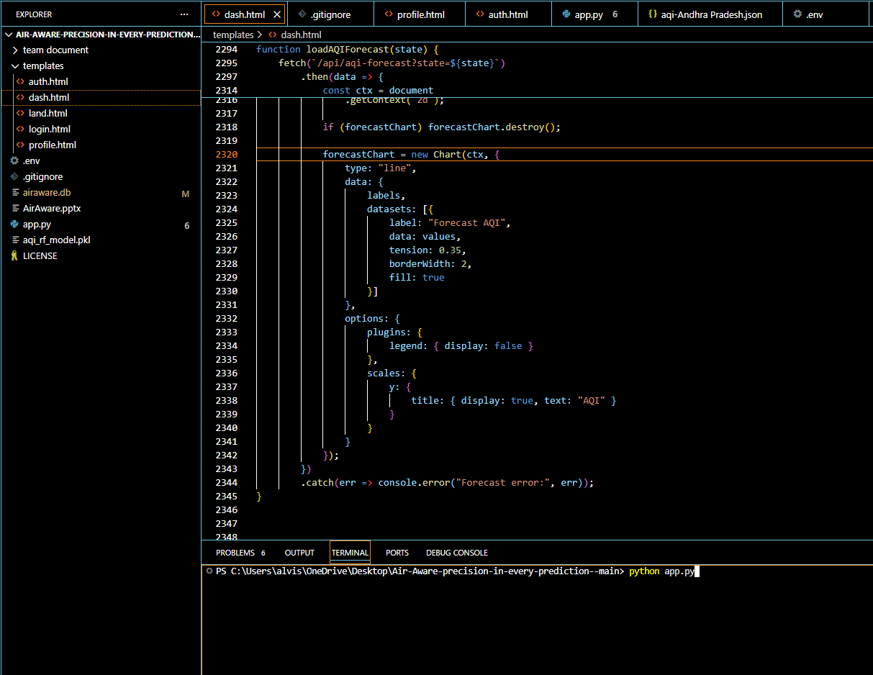

Running the Flask app using the command python app.py in the terminal.

Copying or clicking the local server link provided by Flask (http://127.0.0.1:5000).
The home page of the AirAware application appears on the browser. 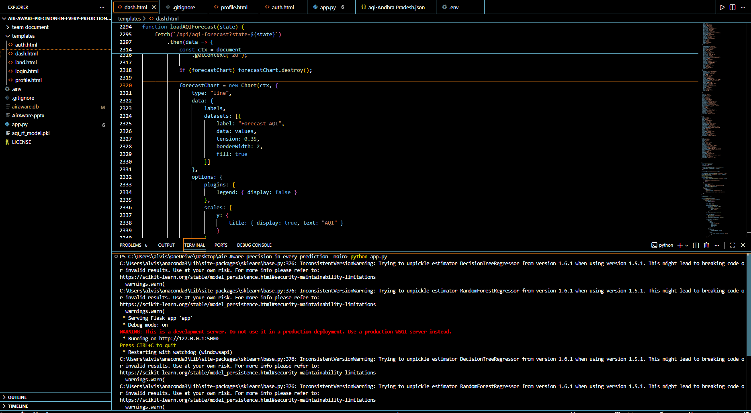

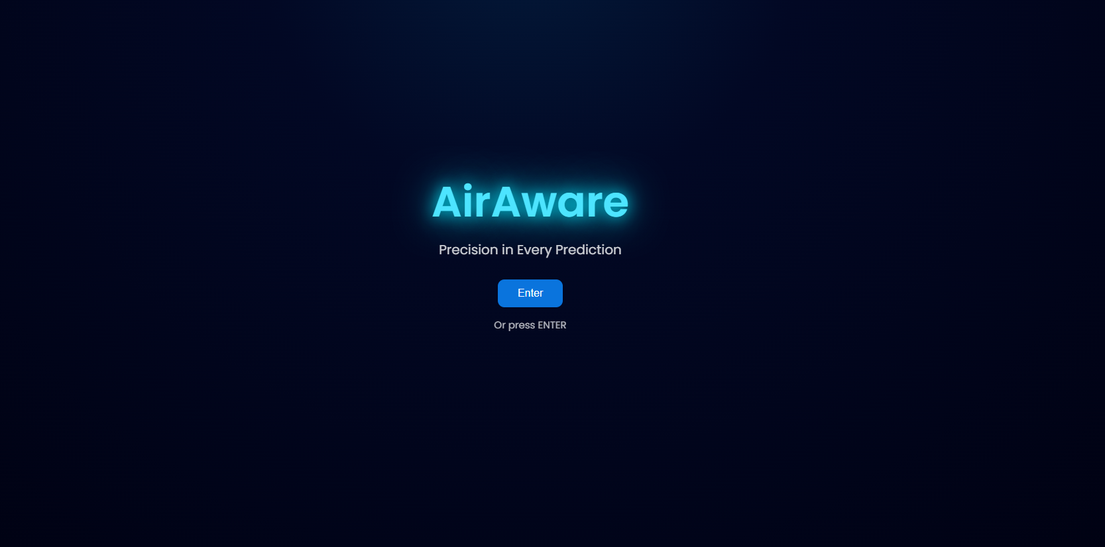
Land page

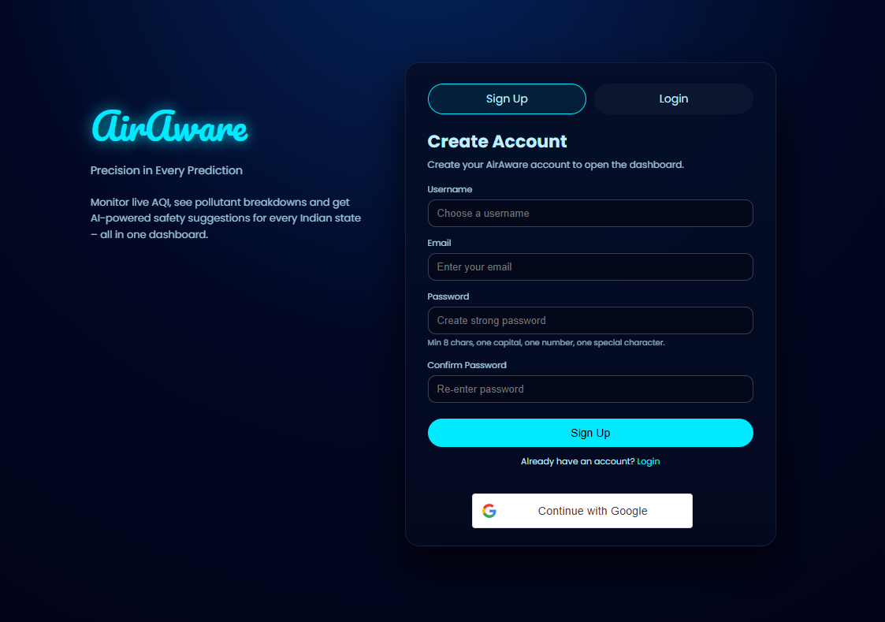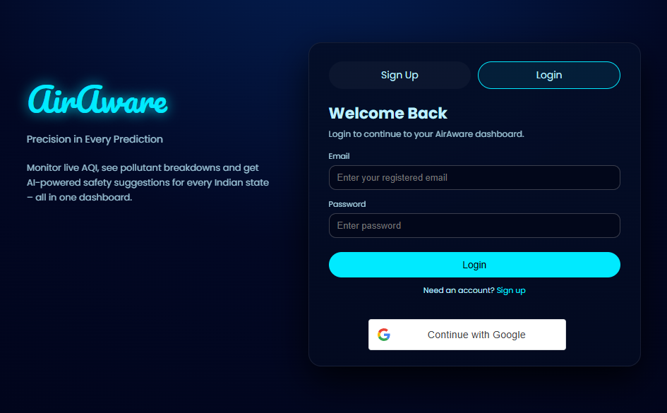
Login page and Sign-up page.

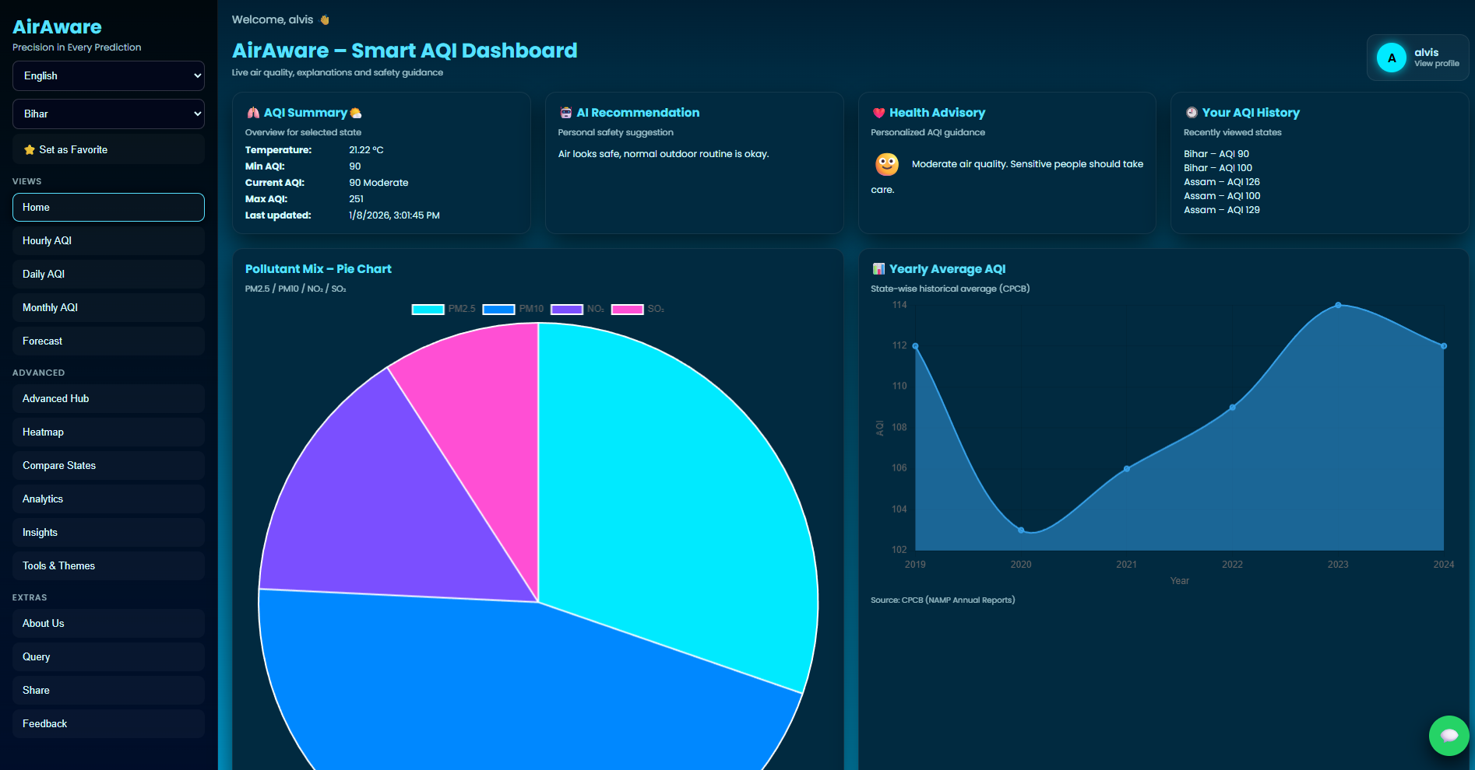
Home page

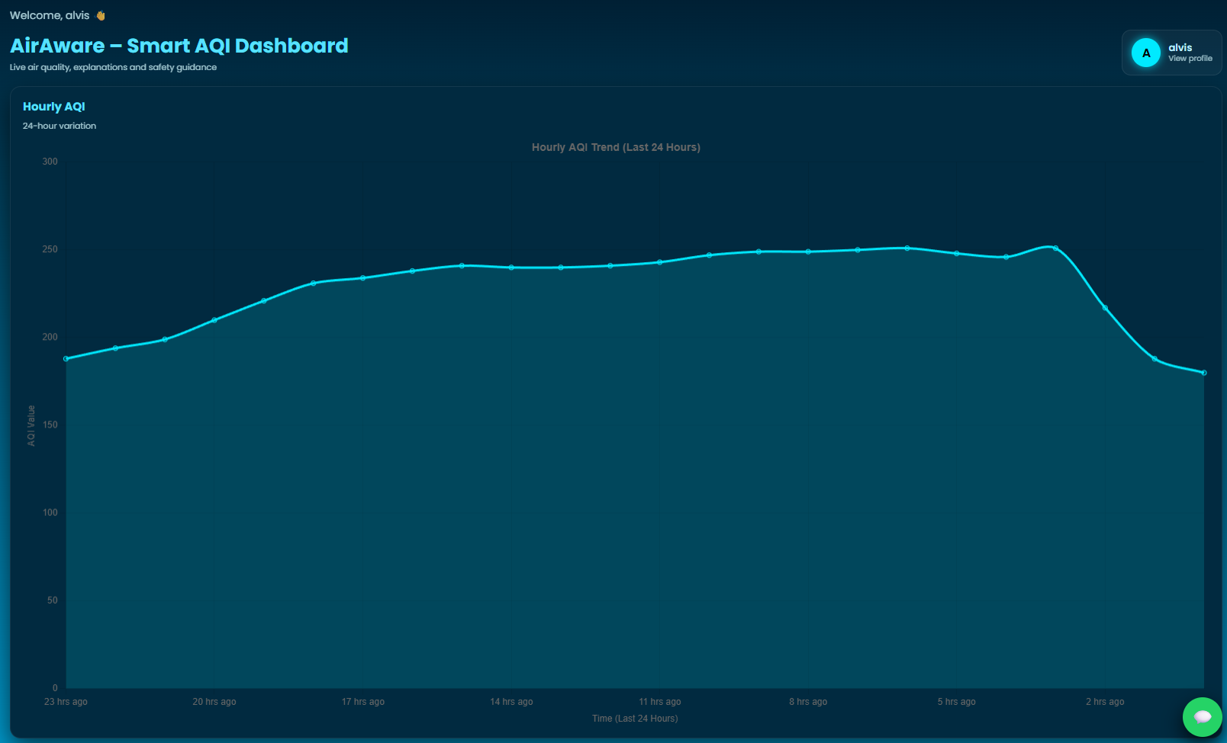
Hourly chart

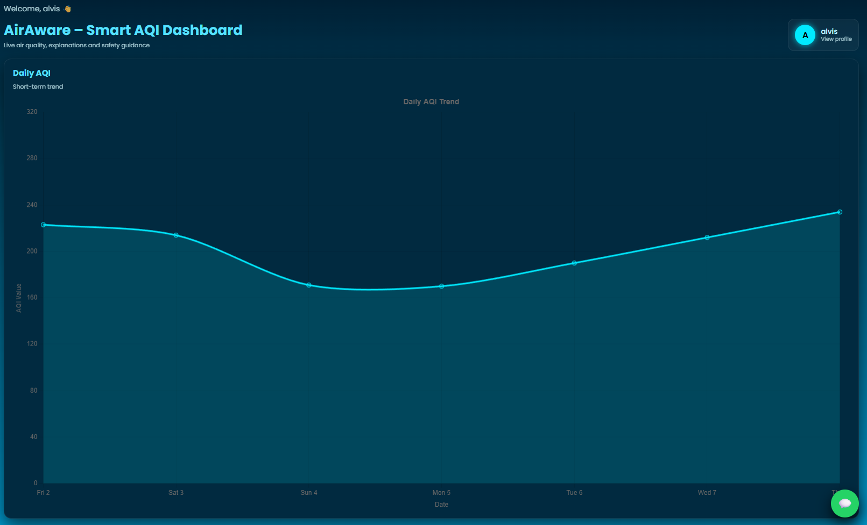
Daily chart

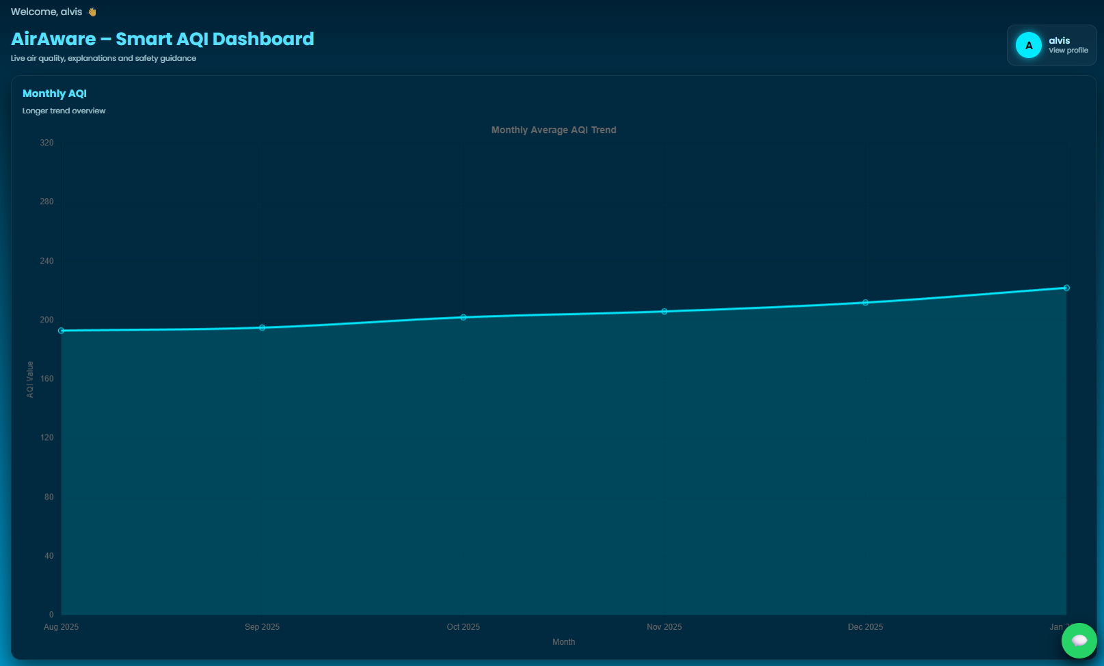
Monthly average chart

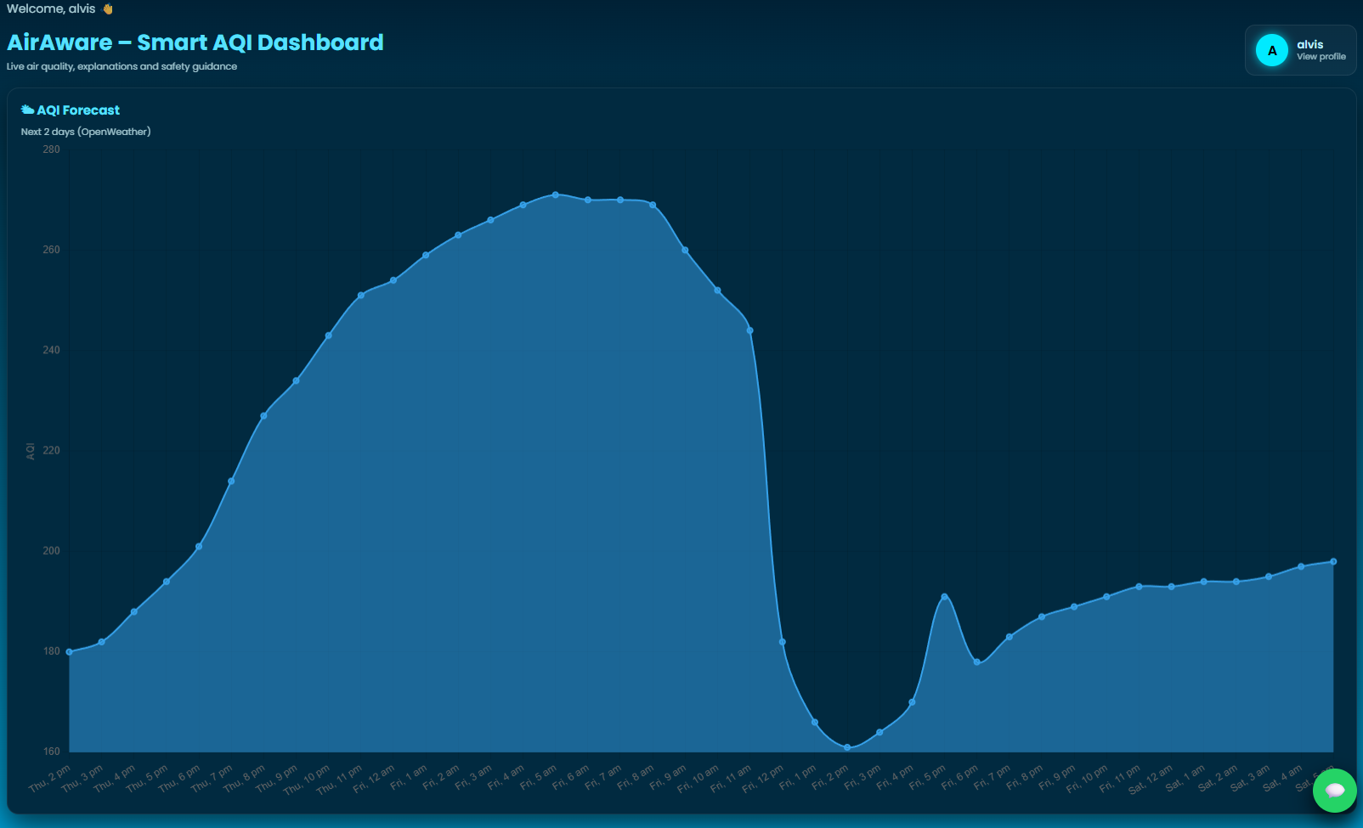
Forecast chart
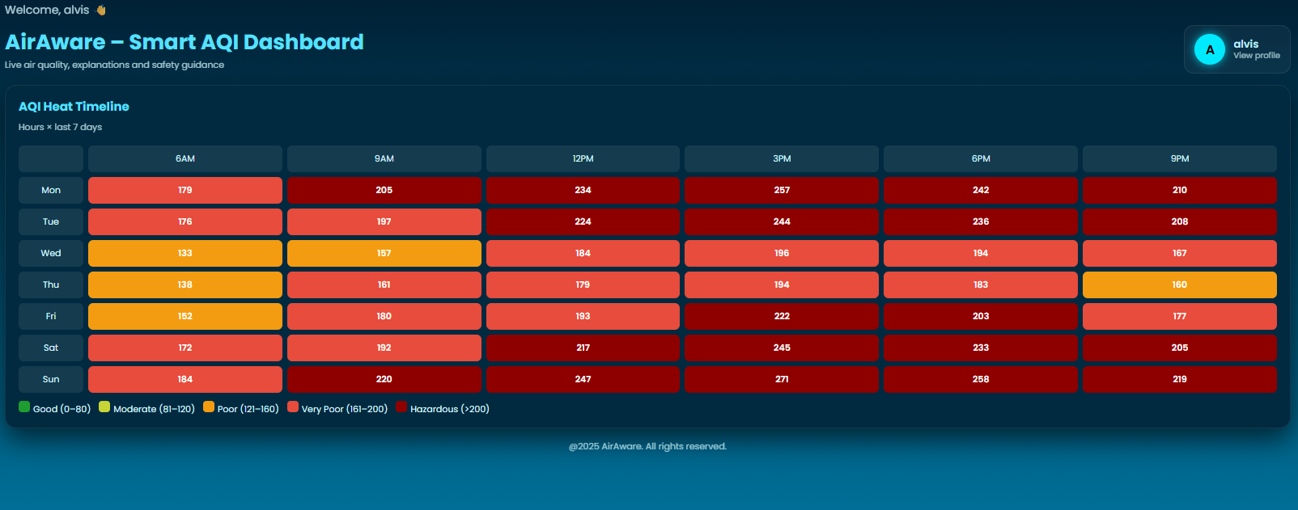
AQI Heatmap of last weeks

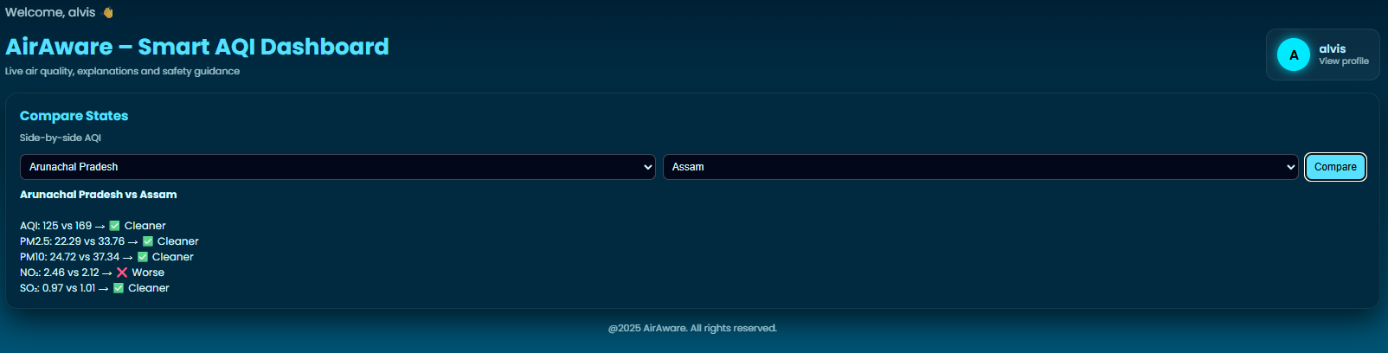
Compares the air quality of two states

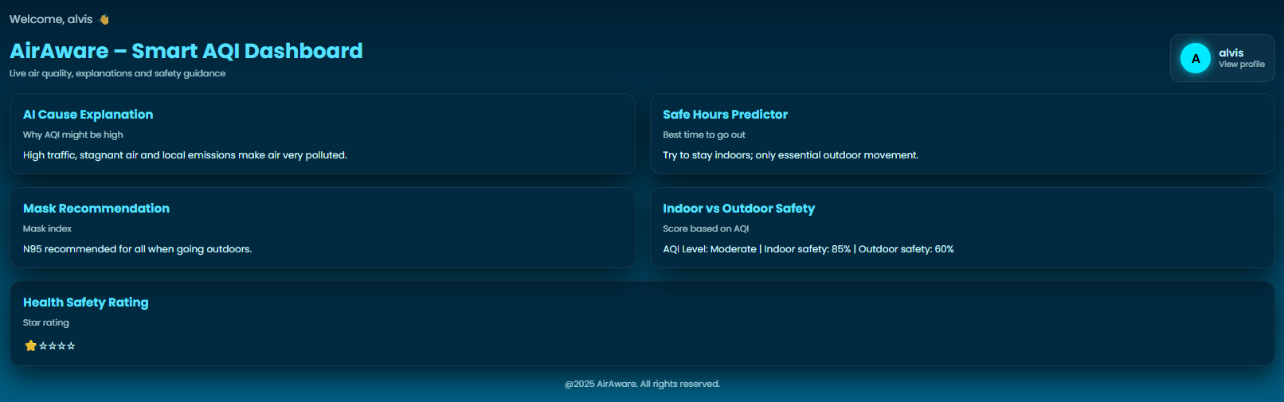
Provides insights based on the AQI of the state.

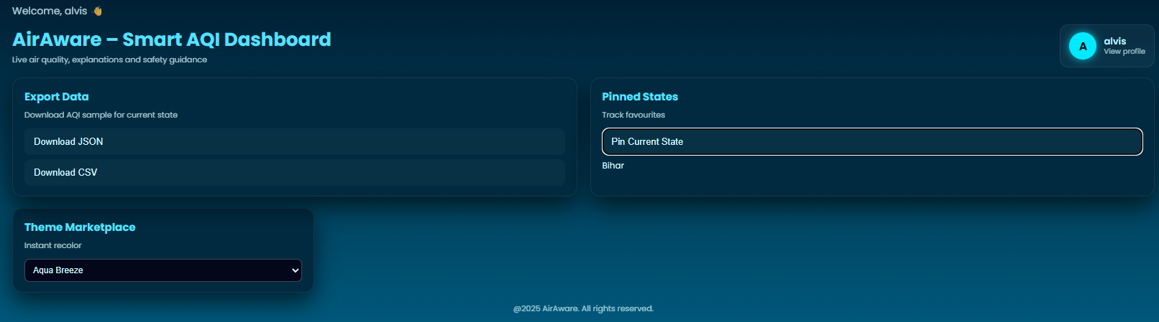
Theme settings and download data as csv or json

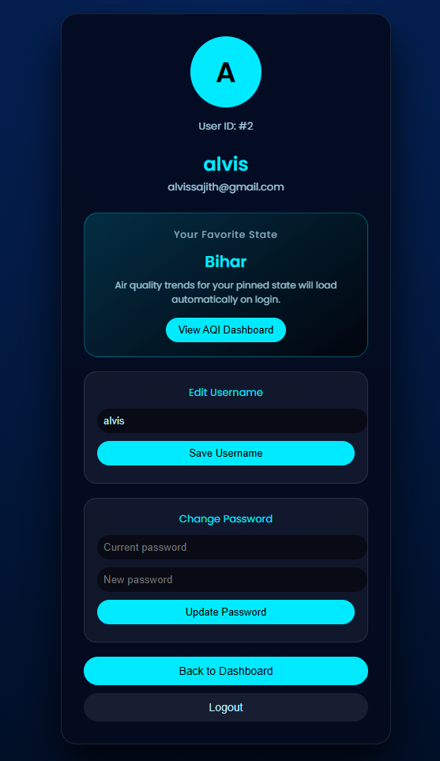
Profile page

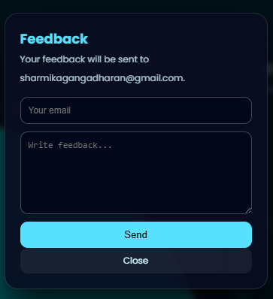
Feedback session

7. Challenges Faced
During the development of the AirAware system, several technical and operational challenges were encountered and addressed through iterative refinement and testing:
1. Integration of Real-Time Air Quality Data
Fetching live pollutant data from the OpenWeather API required careful handling of API response structures, request limits, and network latency. Variations in data availability for certain regions occasionally resulted in incomplete responses, necessitating robust validation and fallback handling in the backend.
2. Machine Learning Model Training and Integration
Training a Random Forest model to compute AQI from pollutant parameters required careful dataset selection and preprocessing. Ensuring that the model’s predictions aligned with real-world AQI trends while maintaining high accuracy involved multiple iterations of training, evaluation, and parameter optimization before successful backend integration.
3. Data Visualization Clarity and Interpretability
Presenting air quality data in an easily understandable format was challenging due to the complexity of AQI metrics. Early chart implementations lacked context, prompting enhancements such as AQI category bands, threshold indicators, and consistent colour coding to improve user comprehension.
4. User Authentication and Session Management
Implementing both traditional email/password authentication and Google OAuth introduced challenges related to session handling, access control, and feature restrictions. Special care was required to differentiate between standard users and Google-authenticated users, particularly for profile management features such as password updates.
5. User Personalization and State Persistence
Allowing users to select and store a favourite state required database schema updates and careful session synchronization. Ensuring that the dashboard automatically loaded the favourite state upon login without affecting performance or user experience required coordinated frontend and backend logic.
6. Cross-Browser and UI Consistency
Maintaining consistent layout behaviour across different browsers and screen sizes was challenging, especially for dynamic charts and dashboard components. CSS adjustments, responsive design techniques, and repeated UI testing were required to prevent layout shifts and ensure a smooth user experience.
7. Testing, Debugging, and Validation
End-to-end testing involved validating API responses, machine learning predictions, chart accuracy, and user interactions. Debugging issues related to asynchronous data loading, null UI elements, and state-dependent rendering required systematic testing and incremental fixes.
Despite these challenges, continuous debugging, validation, and iterative enhancement enabled the AirAware system to achieve stable performance, accurate air quality representation, and an improved user experience aligned with real-world environmental data.

8. Learnings & Skills Acquired
The development of the AirAware air quality monitoring and prediction system resulted in significant technical, analytical, and professional learning outcomes:
1. Understanding of Air Quality Standards and Environmental Data
Gained practical knowledge of air pollution metrics, pollutant concentration units, AQI standards, and health impact categories. Learned how environmental data from public APIs is structured and how it can be interpreted for meaningful public awareness.
2. Real-Time Data Integration and API Handling
Developed hands-on experience in integrating third-party APIs, handling asynchronous data fetching, managing request parameters, validating responses, and dealing with incomplete or delayed data from external sources.
3. Machine Learning for Environmental Analytics
Learned to train and evaluate a Random Forest model for AQI computation using pollutant parameters such as PM2.5, PM10, SO₂, and NO₂. Gained insight into feature selection, model evaluation metrics, and practical deployment of machine learning models within a web application.
4. Backend Development and Secure Authentication
Strengthened backend development skills using Flask, including request routing, session management, database operations with SQLite, and secure user authentication using both email/password hashing and Google OAuth integration.
5. Data Visualization and Dashboard Design
Enhanced skills in designing interactive dashboards using Chart.js to visualize hourly, daily, monthly, and forecasted AQI trends. Learned to improve interpretability using color-coded AQI bands, threshold indicators, and responsive chart layouts.
5. Chatbot integration
Learned how to build a chatbot using grok API and integrate it to the frontend for clearing users doubts
and provide suggestions.
6. User Experience and Personalization
Gained experience in implementing user-centric features such as favourite state selection, profile management, safety score indicators, and multilingual support. Learned how personalization improves usability and engagement in data-driven applications.
7. Frontend Development and Responsive UI Design
Improved proficiency in HTML, CSS, and JavaScript for building responsive interfaces, handling dynamic DOM updates, managing UI state, and ensuring cross-browser compatibility for interactive components.
9. Debugging, Testing, and Performance Optimization
Strengthened problem-solving skills by debugging asynchronous data issues, resolving UI rendering errors, optimizing API calls, and conducting functional and usability testing to ensure system stability.
10. Technical Documentation and Project Presentation
Enhanced the ability to document system architecture, development workflow, challenges, and results in a structured manner suitable for academic evaluation and technical presentations.

9. Testimonials from team
- Team Member 1:
“This project enhanced my skills in training a Random Forest model for AQI prediction and developing backend logic for API integration, AQI computation, and database management.”
- Team Member 2:
“I gained hands-on experience in building interactive dashboards and visualizing AQI data using responsive UI components and charts.”
- Team Member 3:
“Working on both frontend features and backend integration improved my understanding of full-stack development and team collaboration.”

10. Conclusion
The AirAware system successfully demonstrates how real-time data integration, machine learning, and interactive visualization can be combined to address environmental and public health challenges. By leveraging live pollutant data from reliable sources, computing accurate AQI values, and presenting trends through intuitive dashboards, the system delivers meaningful air quality insights to users in an accessible and actionable manner.
Throughout the development process, the project strengthened the team’s expertise in end-to-end system design, encompassing API integration, AQI computation, machine learning model training, backend–frontend coordination, and user-centric interface development. The integration of a Random Forest model for AQI calculation further validated the role of machine learning in enhancing analytical accuracy and supporting data-driven environmental monitoring.
The project also demonstrated that well-designed visualization and safety mapping can significantly improve user understanding of complex environmental data, enabling informed decisions regarding outdoor exposure and health precautions. Features such as short-term AQI forecasting, safety score indicators, and personalized state selection enhanced both usability and relevance.
Overall, AirAware stands as a practical, scalable, and socially impactful application with strong potential for further enhancement, including extended forecasting horizons, city-level analysis, personalized health recommendations, and mobile platform integration. The project reflects a strong foundation in full-stack development, machine learning application, and responsible data interpretation, showcasing technical competence and readiness for real-world deployment.

11. Acknowledgements
We express our sincere gratitude to Infosys Springboard for providing us with an excellent learning environment, industry-level curriculum support, and access to resources that helped shape this project effectively.
We extend heartfelt thanks to Ms. Shakthi Gopalakrishnan, our mentor, for her continuous guidance, constructive feedback, and encouragement throughout the development lifecycle. Her insights played a pivotal role in refining our approach, validating our methods, and enhancing our learning experience.
We also appreciate the support from our faculty members, peers, and family for their motivation, collaboration, and valuable suggestions, which helped us stay committed and deliver the AirAware project successfully

